**DEPARTMENT OF COMPUTER SCIENCE AND APPLICATIONS**

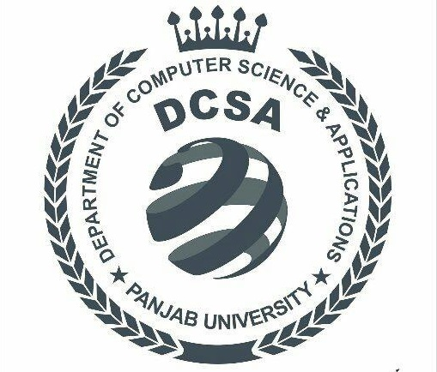

**PANJAB UNIVERSITY**

**CHANDIGARH**



Project Report On RSA Encryption Program

**SUBMITTED TO: SUBMITTED BY:**

**Ms.**  **Abhay Singh**

**MCA-II(Evening)**

**Roll No. 51**

Table Of Content

|  |  |  |
| --- | --- | --- |
| Sr.No. | Name | Pg.No |
| 1 | Introduction to R.S.A |  |
| 2 | Project Description |  |
| 3 | Program Interface |  |
| 4 | Program Features |  |
| 5 | Program Source Code |  |
| 6 | Program Scope |  |

Introduction to R.S.A

Rives-Shamir & Alderman developed the asymmentric